College Of Engineering, Guindy

Anna University Chennai

CERTIFICATE

NAME OF STUDENTS ROLL NO

1) P.NAVEEN RAJ 2009115061

2) S.B.YUVARAJA 2009115118

3) YASHWANTH 2009115119

OF **2009-2013** COURSE IN **INFORMATION TECHNOLOGY** HAVE SUCCESSFULLY COMPLETED THEIR PROJECT WORK ON

**Super Resolution of Land Cover Mapping**

**PROJECT GUIDE : DR K.VANI**

**SIGNATURE :**

**ACKNOWLEDGEMENT**

Our first experience of project has been successfully, thanks to the support of many friends . We wish to acknowledge all of them . However, we wish to make special mention of the following

First of all we are thankful of our project guide Dr K.Vani under whose guideline we were able to complete our project . We are wholeheartedly thankful to her for giving us her value able time and attention and for providing us a systematic way for completing out project in time

INDEX

|  |  |
| --- | --- |
| **TITLE** | **PAGE NUMBER** |
| INTRODUCTION |  |
| LITERATURE SURVEY |  |
| SYSTEM ARCHITECTURE |  |
| ALGORITHIMIC EXPLANATIONS |  |
| IMPLEMENTATON |  |
| RESULTS |  |
| REFERENCES |  |

**Super Resolution of Land Cover Mapping**

**CHAPTER 1 :**

**INTRODUCTION**

**INTRODUCTION OF PROJECT**

Satellite images are used for preparing latest land cover maps, usually maps are prepared through classification. Classifications may be hard classification or soft classification. Hard classification is mapping of the one pixel to one class approximately. So in hard classification class cannot be mapped correctly. So we go for Soft Classification, Soft classification is finding of percentage of spectral components in the particular pixel and Super Resolution Mapping is the technique that is used to map the identified spectral components in a particular pixel.

**Land Cover Maps :**

**Land cover** is the physical material at the surface of the earth. Land covers include grass asphalt , trees , bare ground, water etc. There are two primary methods for capturing information on land cover: field survey and analysis of [remotely sensed imagery](http://en.wikipedia.org/wiki/Remote_sensing) . Land cover is distinct from [land use](http://en.wikipedia.org/wiki/Land_use) despite the two terms often being used interchangeably. Land use is a description of how people *utilize* the land and [socio-economic activity](http://en.wikipedia.org/wiki/Socioeconomic_development) - [urban](http://en.wikipedia.org/wiki/Urban_area) and [agricultural land](http://en.wikipedia.org/wiki/Agricultural_land) uses are two of the most commonly known land use classes. At any one point or place, there may be multiple and alternate land uses, the specification of which may have a [political](http://en.wikipedia.org/wiki/Politics) dimension. The origins of the ‘land cover / land use’ couplet and the implications of their confusion are discussed in Fisher.One of the major land cover issues (as with all [natural resource](http://en.wikipedia.org/wiki/Natural_resource) inventories) is that every survey defines similarly named categories in different ways. For instance, there are many definitions of ‘[Forest](http://en.wikipedia.org/wiki/Forest)’, sometimes within the same organisation, that may or may not incorporate a number of different forest features (stand height, canopy cover, strip width, inclusion of grasses, rates of growth for [timber production](http://en.wikipedia.org/w/index.php?title=Timber_production&action=edit&redlink=1)). Areas without trees may be classified as forest cover *if the intention is to re-plant* (UK and Ireland), areas with many trees may not be labelled as forest *if the trees are not growing fast enough*(Norway and Finland).

**DRAWBACK OF PRESENT RATION SHOP SYSTEM :**

* Present system is not automated and present system
* Is purely based on book
* If someone else got the card of other family he also can buy items
* Employers of the ration shop can do mall practice in stocks maintained
* Checking is purely manual

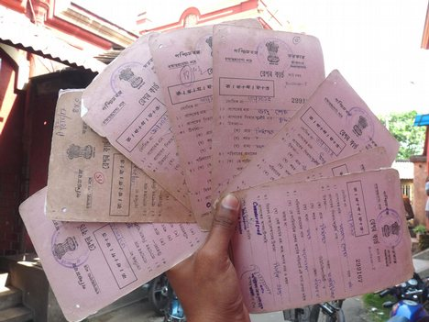( figure : showing the duplicate ration cards )

* Stock checking is also purely manual

**OUR PROJECT :**

**“AUTOMATED RATIONSHOP SYSTEM”** is the project that is used to automate the present ration shop system and to reduce the flaws in the present system . This project uses RF ID card for each family instead of the ration card and the card type is chosen when registering the card and while registering the card finger prints of the family members also registered with the card . Once the card is registered any member of the particular family can buy the items available for that card . If the item is already purchased in the particular month he will not be able to purchase the same item again in that month . After every purchase sms will be send to the head of the family regarding the purchase with that card . Stock updating can be done only by the employee of the ration shop using the admin login and password and if the items in the stock got below the threshold pop up will be shown indicating that the stock is low

**VIEW OF EMPLOYEE OF RATION SHOP ABOUT OUR PROJECT :**

When enquiring the employee of ration shop about our project they told that the concept of this project is so far good and if this project is implemented corruption in the ration shop will be greatly reduced and in this project no duplicate ration card chance is there and Finger print verification for every purchase is innovative idea

**Chapter 2 :**

**System Architecture**

**Chapter 3 :**

**IMPLEMENTATION**

**REGISTRATION :**

**MAIN WINDOW :**

Main window will have various options available like registration , purchase , admin login for the registration purpose.

**REGISTRATION :**

Each family will be given one RF – ID card this card will act basically like the ration card . using this RF – ID card only any registered member of the family will be able to purchase items available for that card once in a month.

**RF – ID INPUT :**

This window allows you to give your RF – ID input it is basically nothing but showing your RF – ID card on the RF – ID scanner . RF – ID scanner will be connected to the serial port terminal input will be get from the serial port terminal with the help of the StreamReader . On getting input from the RF – ID card it will lead to the next window ( registration )

**PERSONAL DEAILS INPUT:**

This window will get user details from the user and this will also get family head photograph of every family member . On adding one member of the family it will allow to enter details about the other member of the family once the registration of all the members of the family is complete this window will be closed

**ENROLL FINGERPRINT :**

Clicking add detail for particular person it will allow one to choose the finger to enroll . After choosing the finger it will ask for 4 sample of the same finger print if all the finger print matches to 20% then the all the details about the particular person will be added to the data base

**Purchase :**

**Verification :**

Before entering to the purchase identity of the person is checked with the help of the biometric system and the RF – ID scanner . First it will prompt for the RF – ID input . After this it will ask u to give registered finger print it will be checked against the finger prints registered for the particular card . After the input matches identity is verified and the purchase screen will be visible for the person

**Purchase :**

After the verification process purchase screen will be visible for the person . In the purchase screen items available for that card will be visible and the max quantity available for that card will be also shown . On giving the quantity of the items to be purchased availability of the items in the stock is check . If the items are available in the stock one can purchase the items . After the purchase is made SMS contains details of the purchase will be send to the family head

**SMS process :**

For the SMS purpose API is purchased from the vendor . On purchasing API one DLL file will be given . On calling the function in the DLL file SMS will be sent

**LED display :**

After the every purchase is over using one serial port terminal object message opened is displayed on the LED indicating that the cash handling can be done only after the purchase

**STOCK UPDATION :**

**ADMIN LOGIN :**

On clicking the admin option in the main window it will prompt for the admin login screen . On giving the username and password of the admin it will lead to the stock updating form

**STOCK UPDATING :**

In the stock updating form all the available items in the ration shop will be visible on entering quantity and clicking add on the particular item added quantity will be added in the stock . It will take place on the every stock updating

**SUMMARY :**

This chapter gives details about the implementation of the project

**Chapter 4 :**

**RESULTS AND EVALUTATION**

**Working action :**

Welcome to ‘ Ration shop System ‘

Each family will be given one smart card which contains the smart card id. The Database in the system will have the information of smart card id’s finger prints of family members with their details, mobile number of family head and the last purchased details.

Authentication is done by a BIOMETRIC SYSTEM which accepts the smart card and a finger print. Finger print matching is checked between the finger input and the finger print details in the database through the finger print matching algorithm. Smart card id (primary key) is used for the purpose of faster access so that there is no need of searching the whole database (finger prints belonging to that locality are taken from a centralized set of finger prints). If the match is correct the person is allowed inside. The person then enters the next system which shows all the items and with a weight scale of them .when the scale is moved to the required quantity item availability is indicated by editable (if available) and not editable (if not available) .when check is pressed the item price will be displayed and consolidated items purchased will be displayed. This system also contains a reset button to reset the order if any mistake has been made. Once the order is finished final button is pressed which makes the system to send SMS and opens the cash counter.

When the item is added to the stock it will be updated in the system and when the customer purchases the stock gets reduced in the system so that the employee cannot sell the items to the outsiders. Since the database in the system contains all the family details it is very easy to take census . So that the system will increase the stability and the security in the ration shops

**IN OUR PROJECT :**

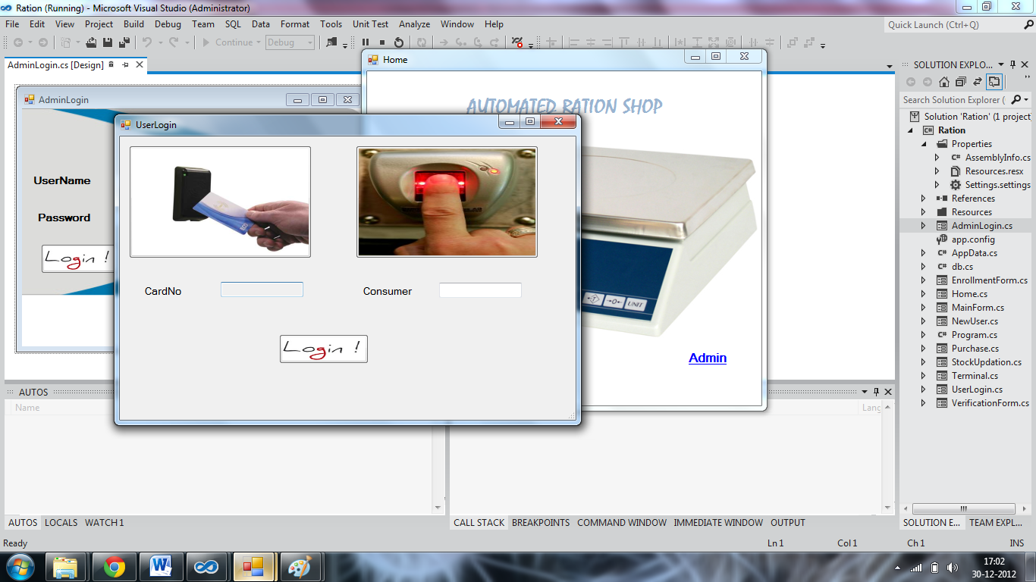

1. **LOGIN FORM :**

This form is used for scanning the RF ID card and getting the finger print for the verification of the user

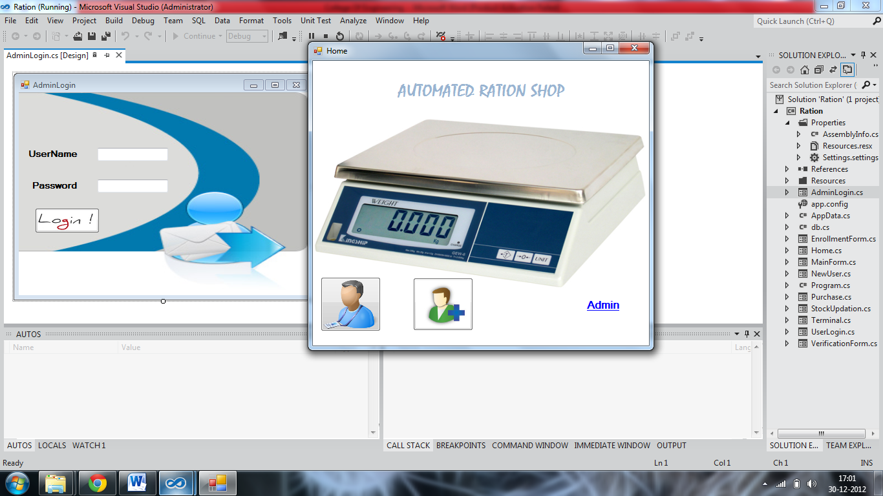

1. **MAIN FORM :**

In the main form you can choose which option you want to choose one already can go into verification process otherwise registration process if it was the admin wants to add some stocks can go to admin option

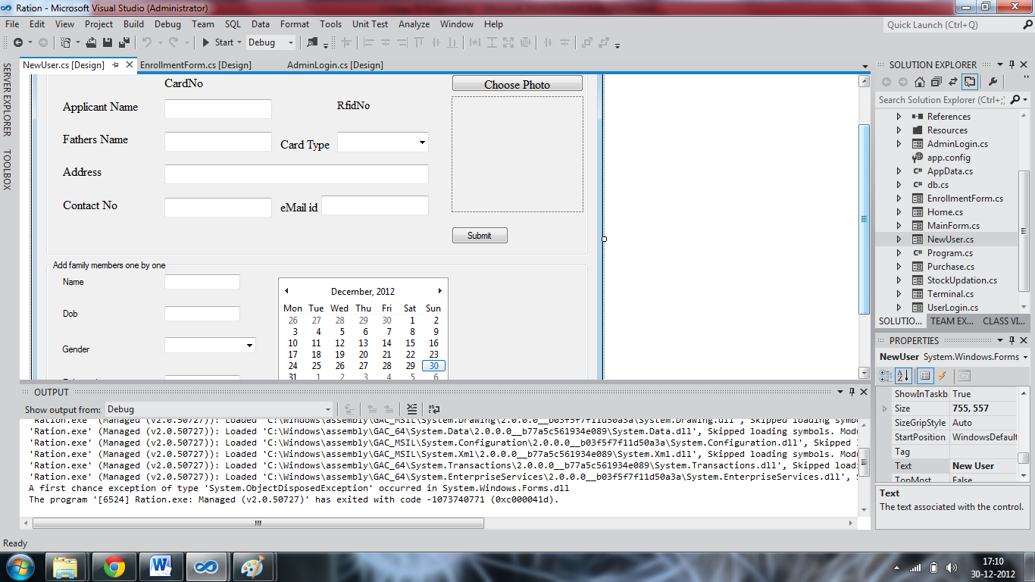

1. **REGISTRATION FORM :**

This form used for registration of the new user . in this form itself all the details of the family members can be added and the photo of the head of the family will be added

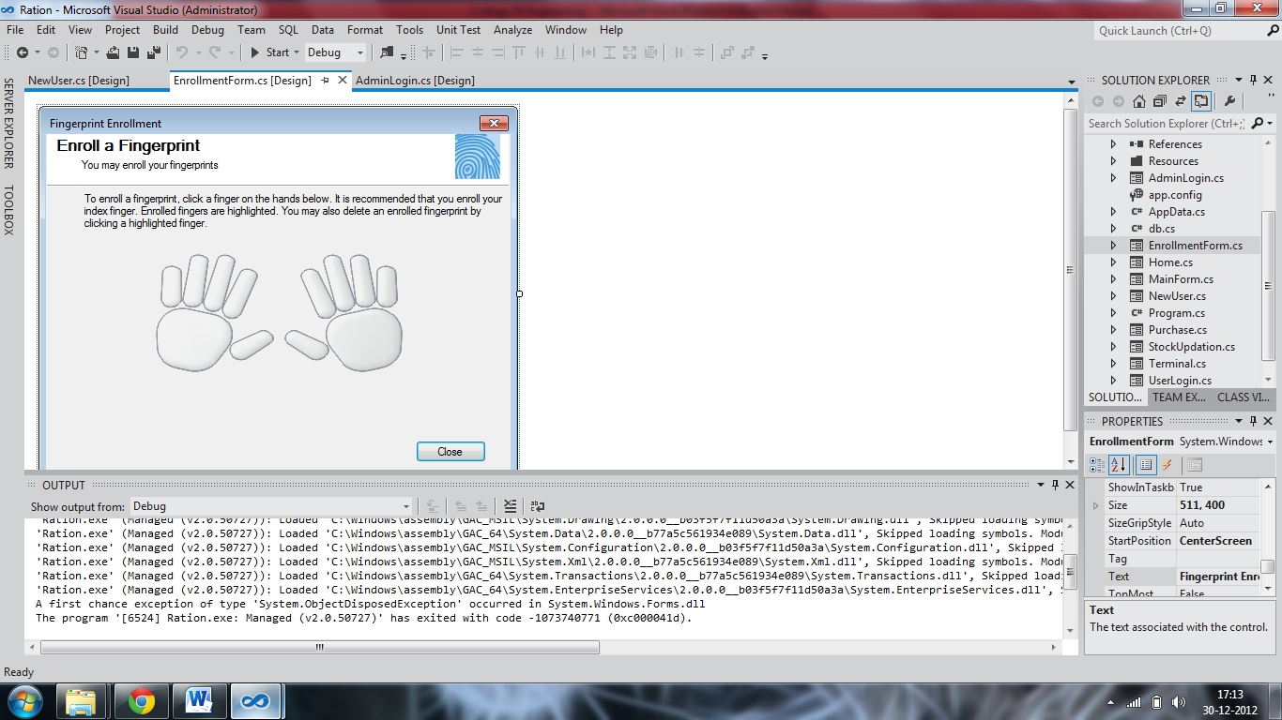

1. **FINGER PRINT ENTRY FORM :**

Using this form the finger print of the all the family members will be added

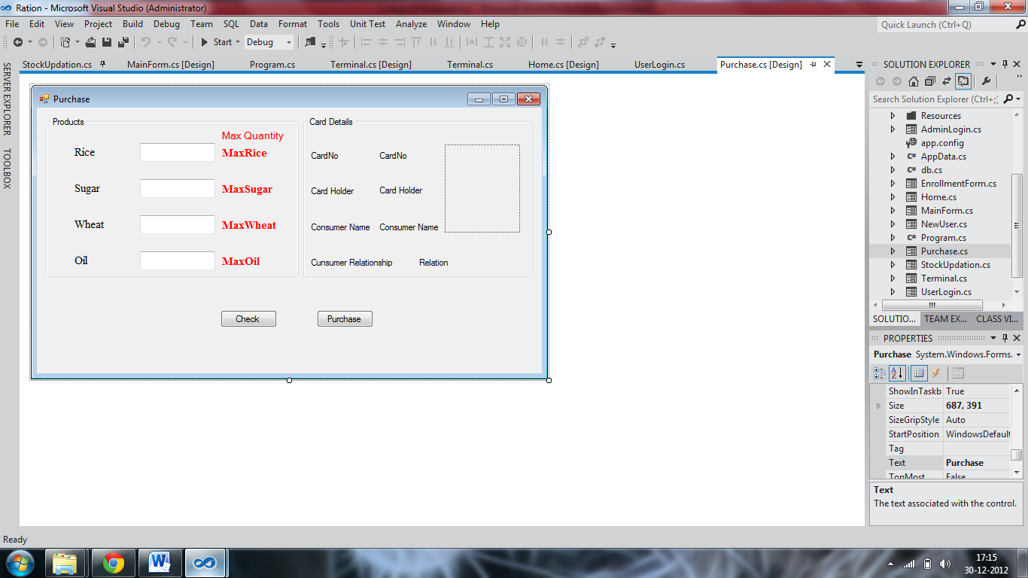

1. **PURCHASE FORM :**

In the purchase form the available items for the card will be in the editable with the max quantity available . if it is already purchased all the items will be in the un editable form

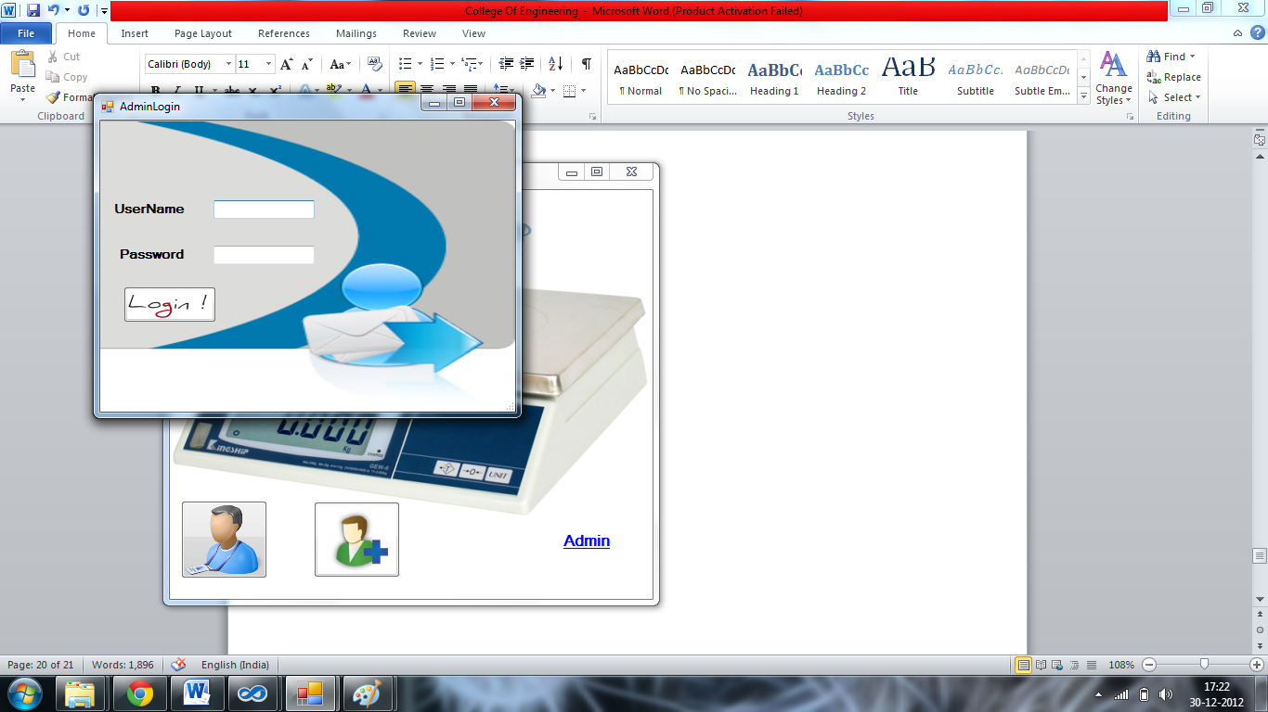

1. **ADMIN LOGIN FORM :**

In this form admin is allowed to enter the user name and password and allowed to enter the stock update form

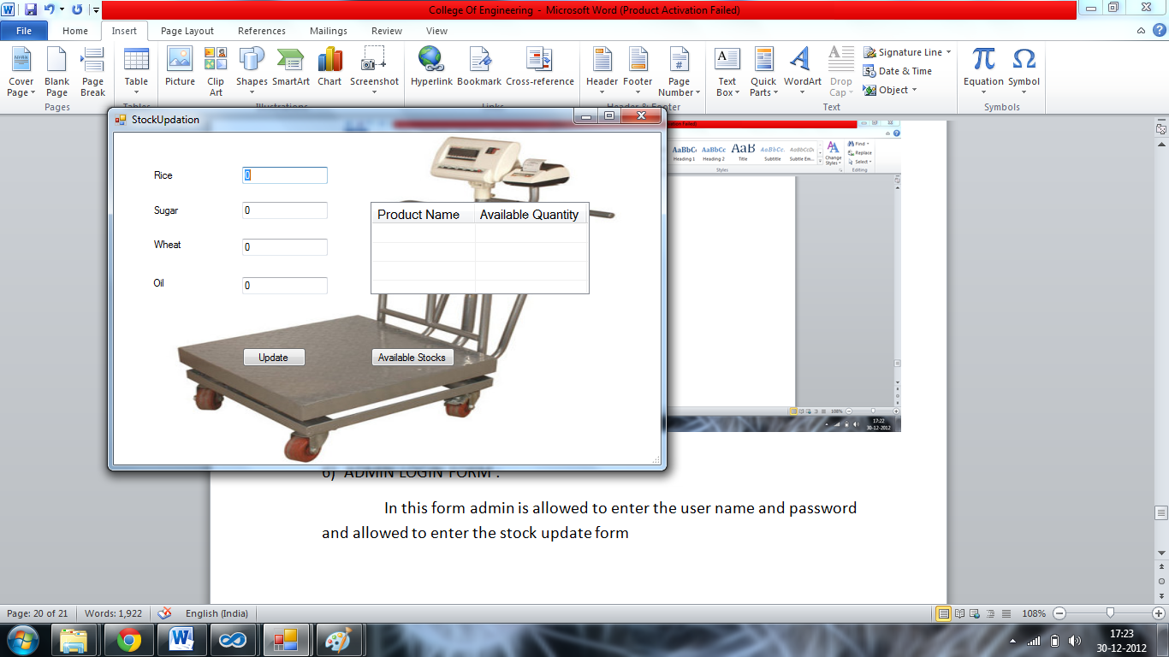

1. **STOCK UPDATE FORM :**

In this form the admin is allowed to update the stock in the database

**SUMMARY :**

This chapter provides working of the model and it gives the better understanding of the ration shop system

**Chapter 5 :**

**TESTING**

**When RF ID scanner is connected :**

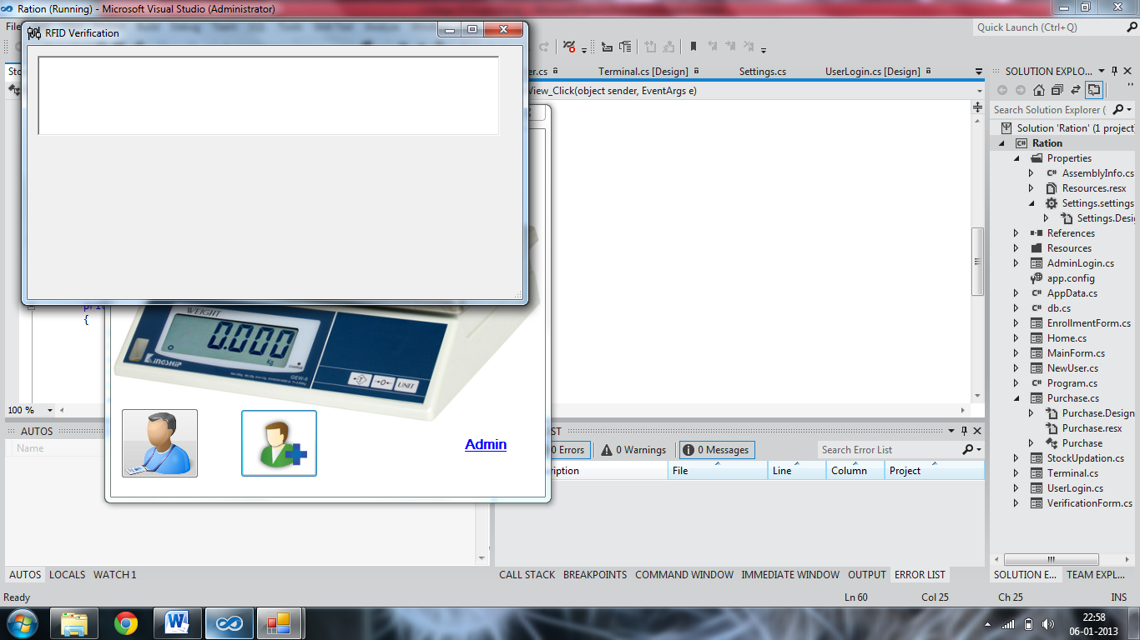

When RF ID scanner is connected when the registration is clicked window will open asking for serial port input from the RF – ID scanner . you cannot type manually on the text box

**When RF – ID scanner is not connected :**

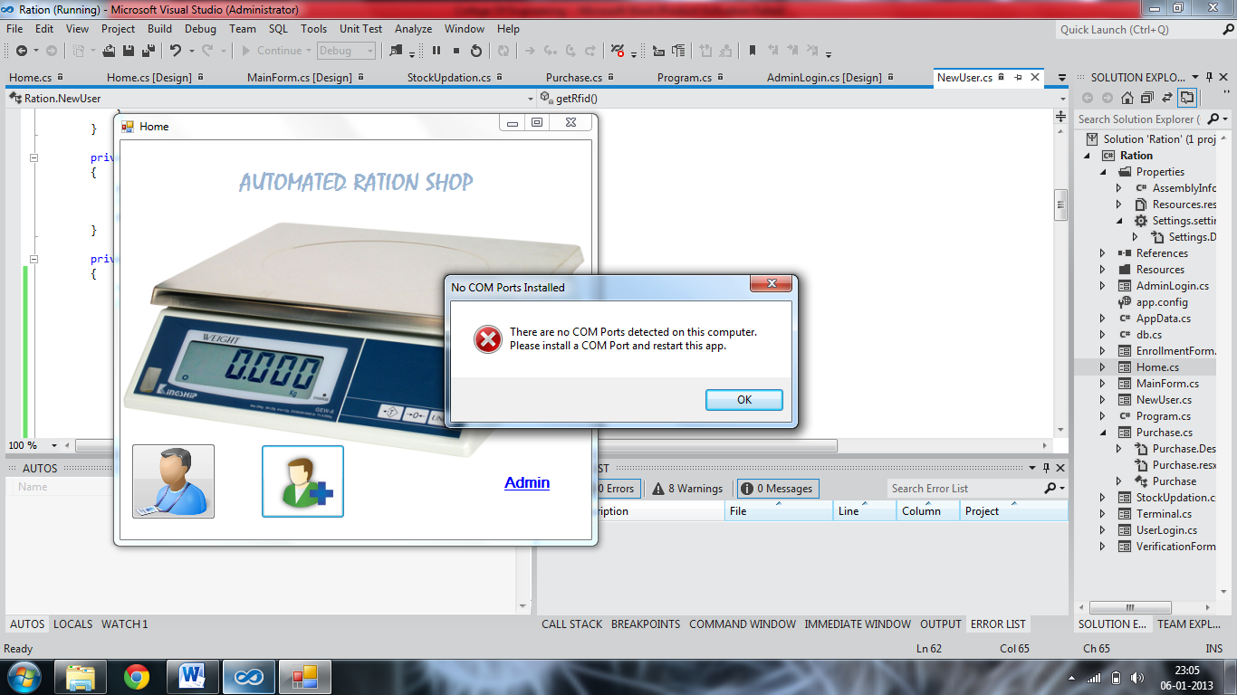

When the RF – ID scanner is not connected it will throw an error saying that the com port is not connected

**When something in the registration is not filled :**

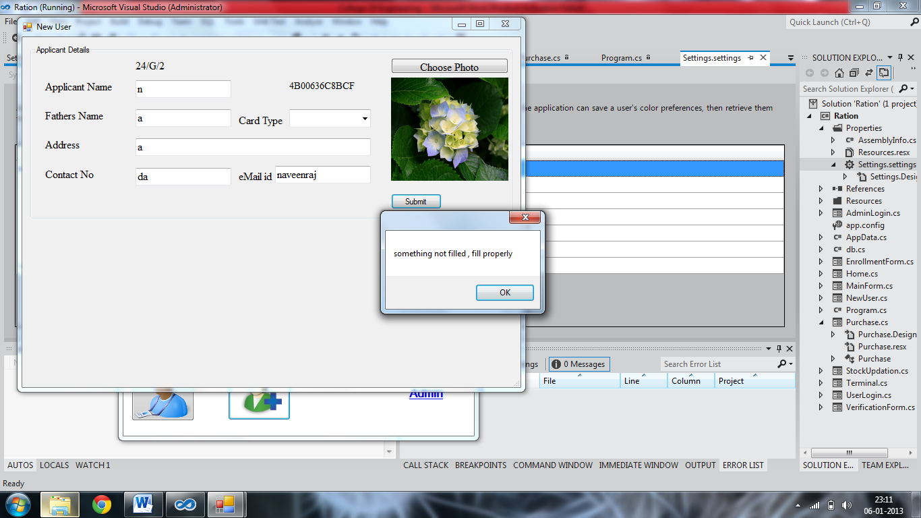

When something is not filled in the registration form it will display one pop up telling that something is to be filled is missed

**When is finger print is not enrolled properly :**

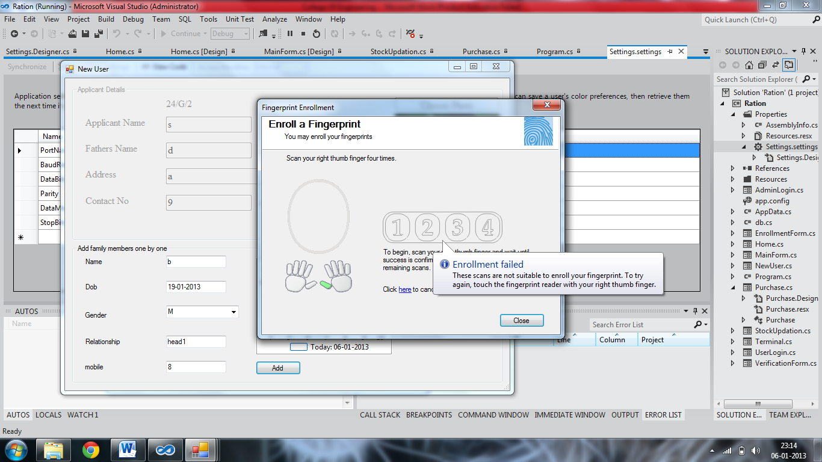

When the finger print enrolment is not done properly it will display that enrolment failed and ask us to enrol again . In this it will collect 4 samples of the same finger print and compare with all 4 and all 4 has to be matched at least of 40%

**When the card that is not registered is used for purchase :**

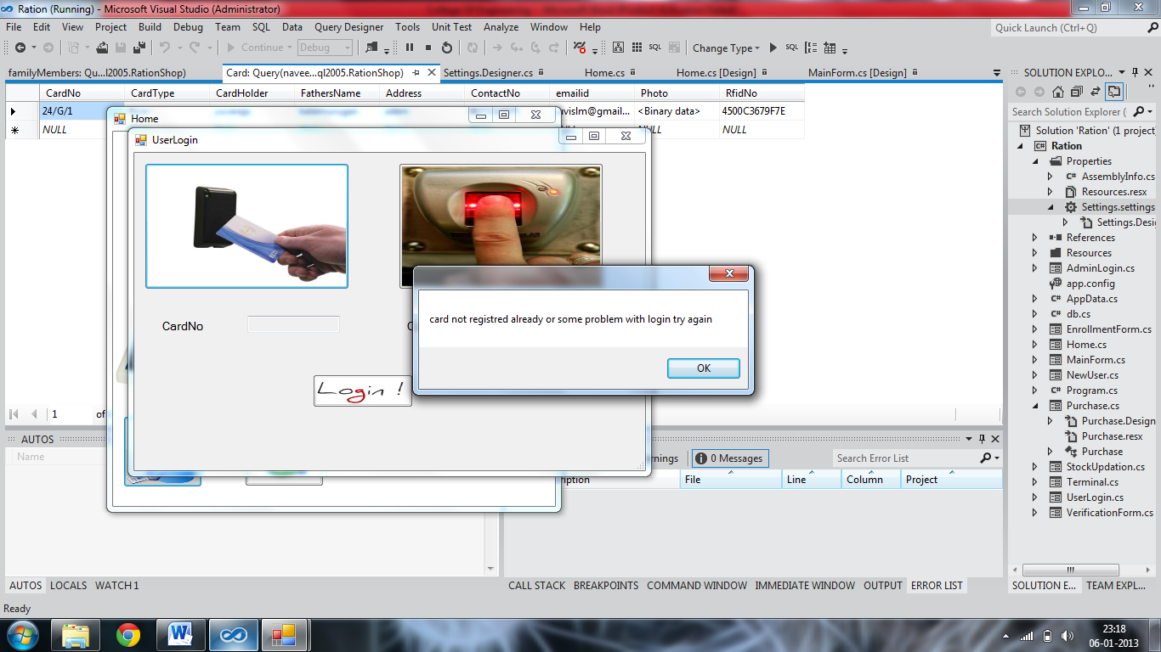

When the card that is not registered already is used for purchase it will display the error message saying that card that you are using to login is not registered already

**When finger print not matches :**

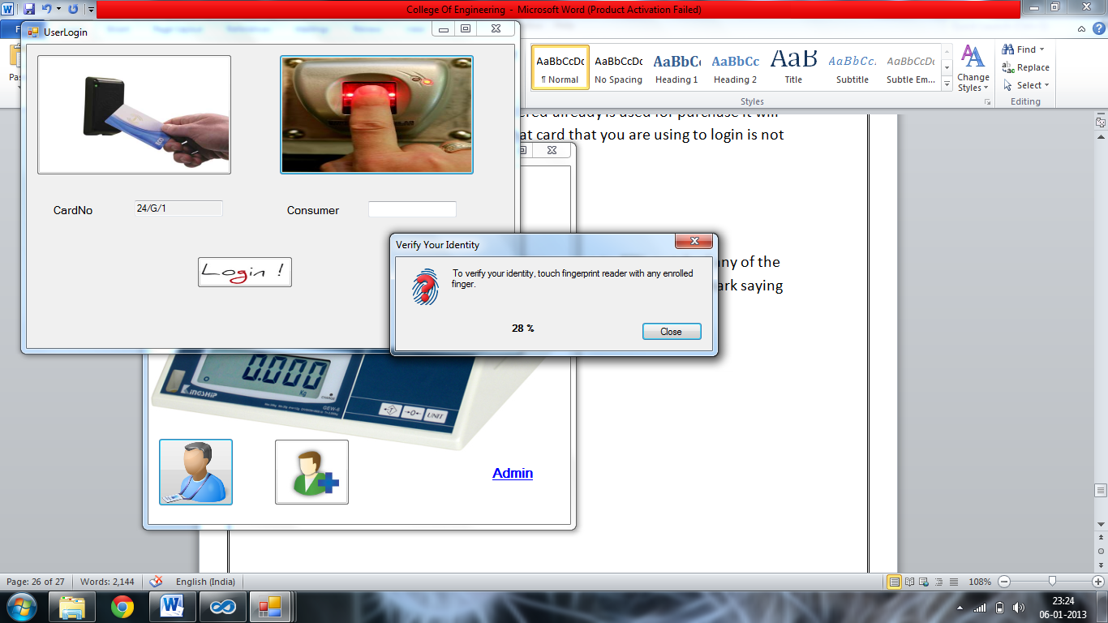

When the finger print used for login is not up to 50% match of any of the finger print registered for that card it will display one question mark saying that finger matches only up to certain percentage

**When the SMS delivery failed :**

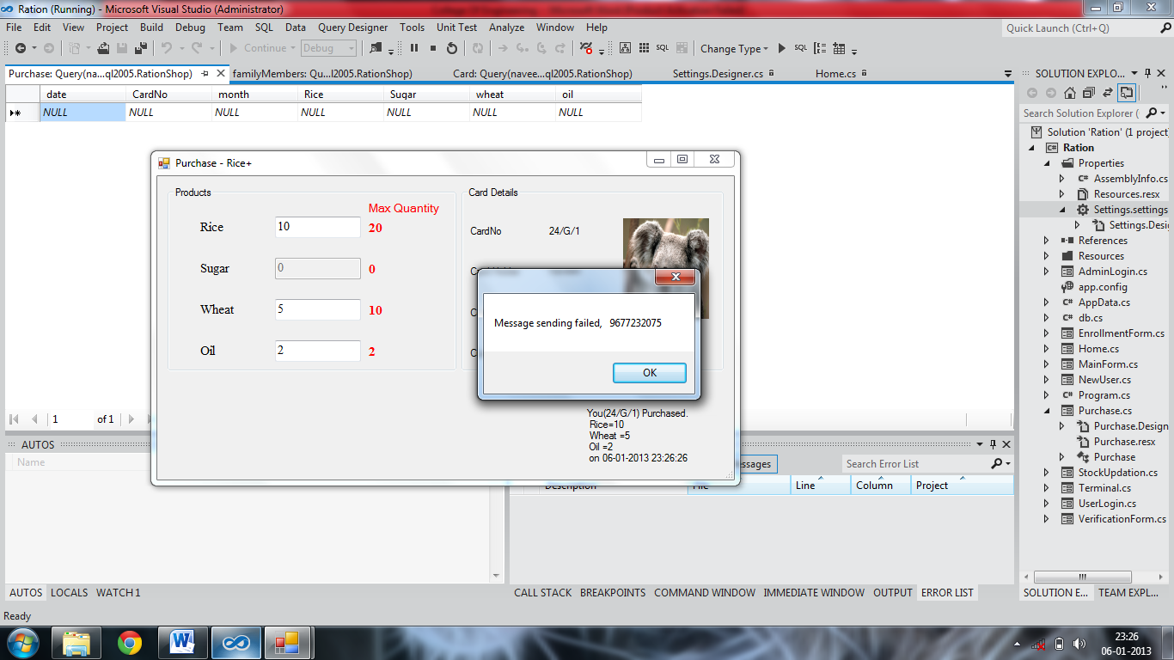

When the SMS delivery failed it will display one pop up saying that SMS delivery failed due to some technical reasons

**When the stock is low :**

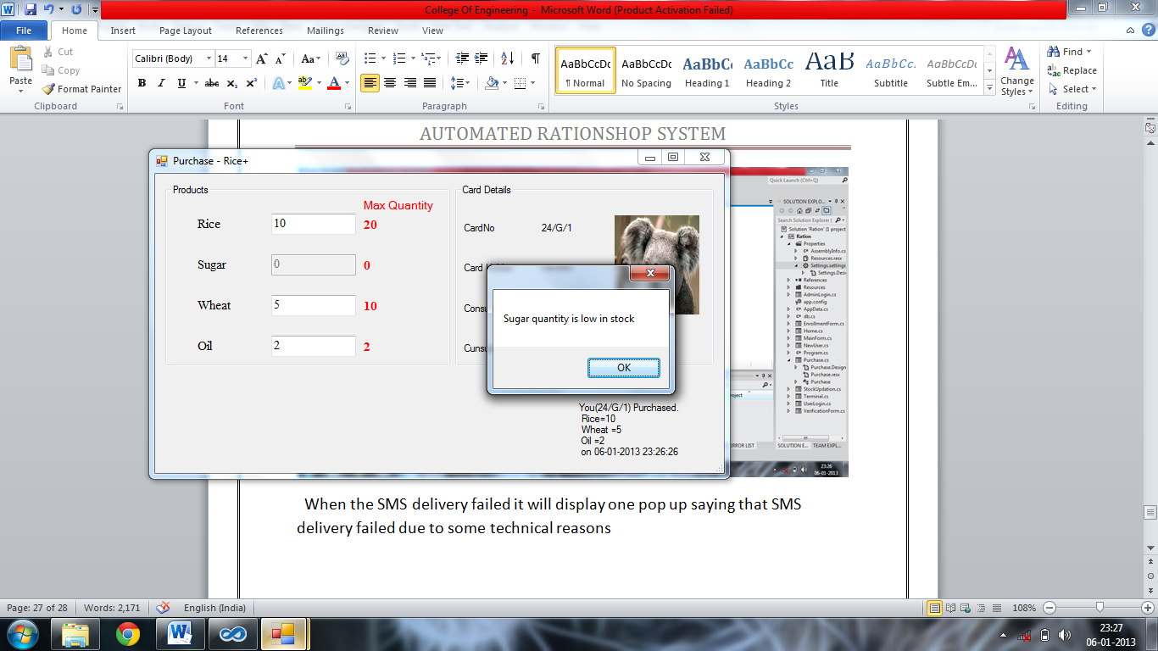

When the stock is low for particular item pop up will be displayed showing that item quantity is low in stock . stock checking is done automatically after the every purchase

**When LED display not connected :**

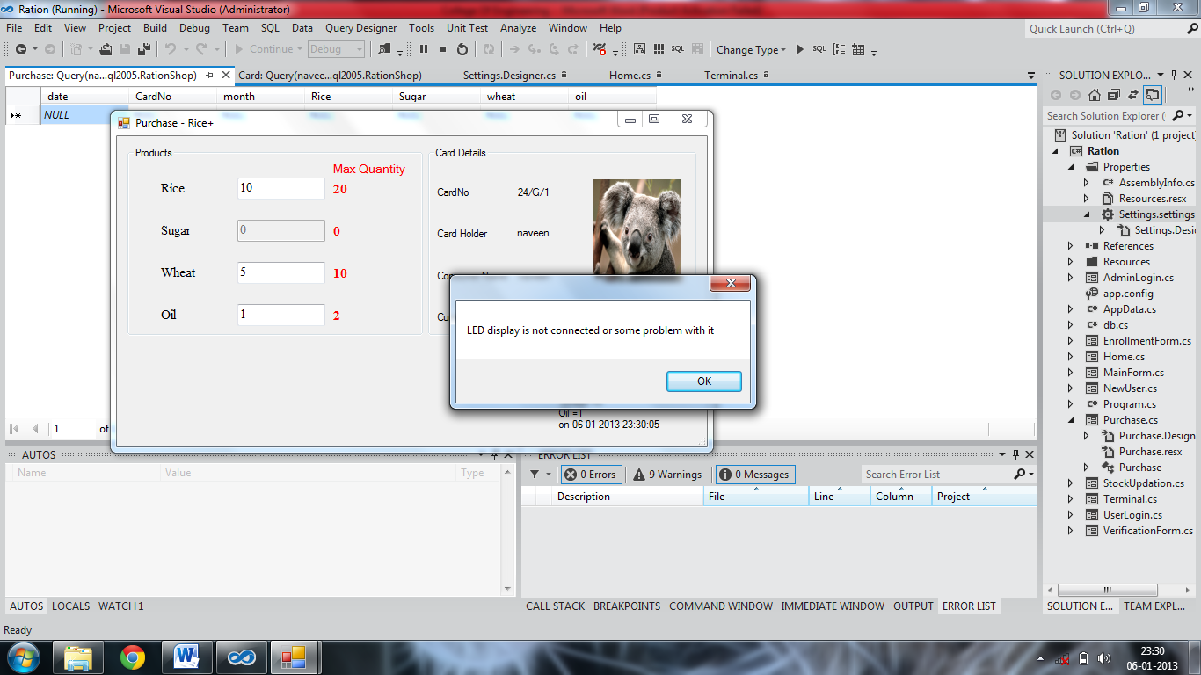

When LED display is not connected it will display one pop up saying that the LED display is not connected or there is some problem with the LED display

**Admin login failed :**

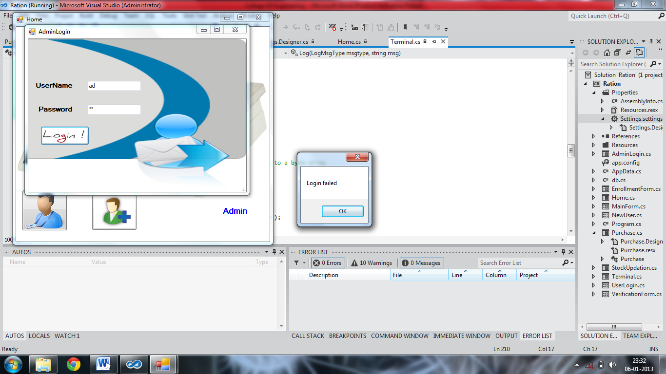

When the admin login failed it will display error saying that the admin login failed

**Summary :**

This chapter gives us the clear idea about the various exceptions that can occur and how they are handled for the proper function of the system

**Chapter 5 :**

**REFERENCES**

This section gives you the name of the books required for the development of the project

**NAME OF THE BOOK AUTHOR**

1. Visual studio complete reference Noel jecke
2. Programing in C# Balagurusamy

And also various web sites are referred for some help needed for working in visual studio